Embry, Brandon
Annotated amended autopsy. There are many things in question, much more than what is annotated. He had arterial blood spray from the back, vertebral artery. There is a split in his neck on autopsy photos. She did not indicate any bruising nor the split in neck, or the bruising around his neck.

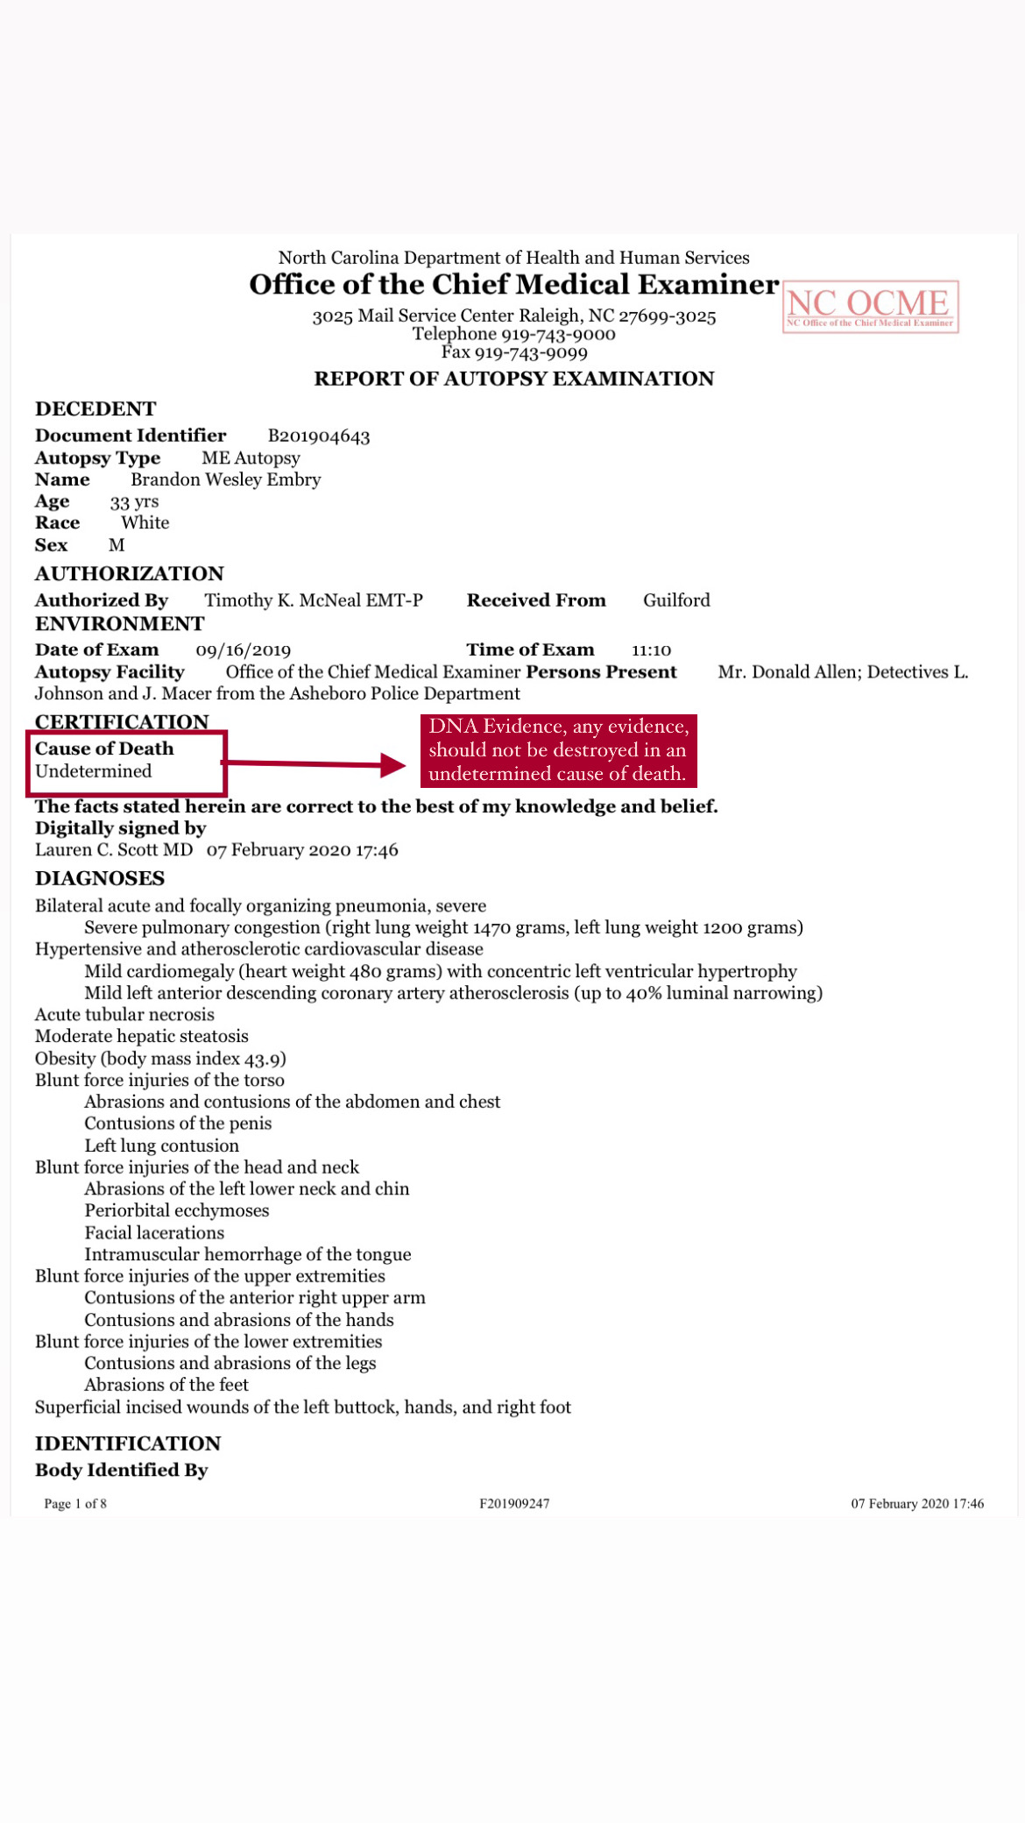

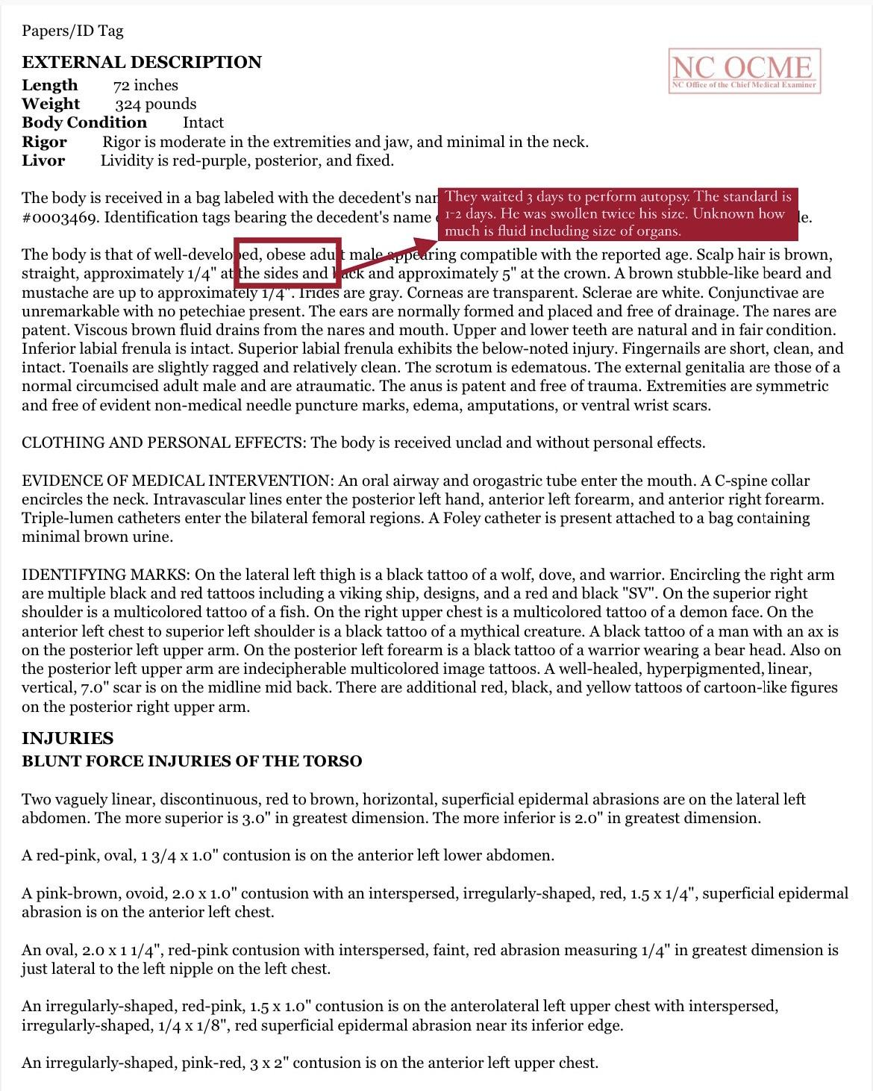

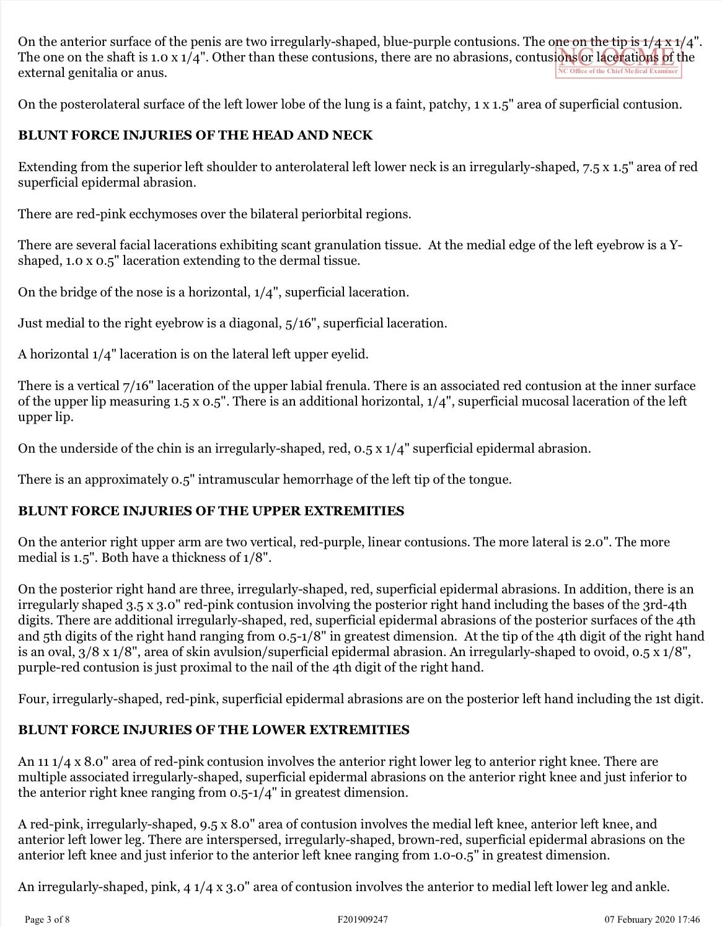

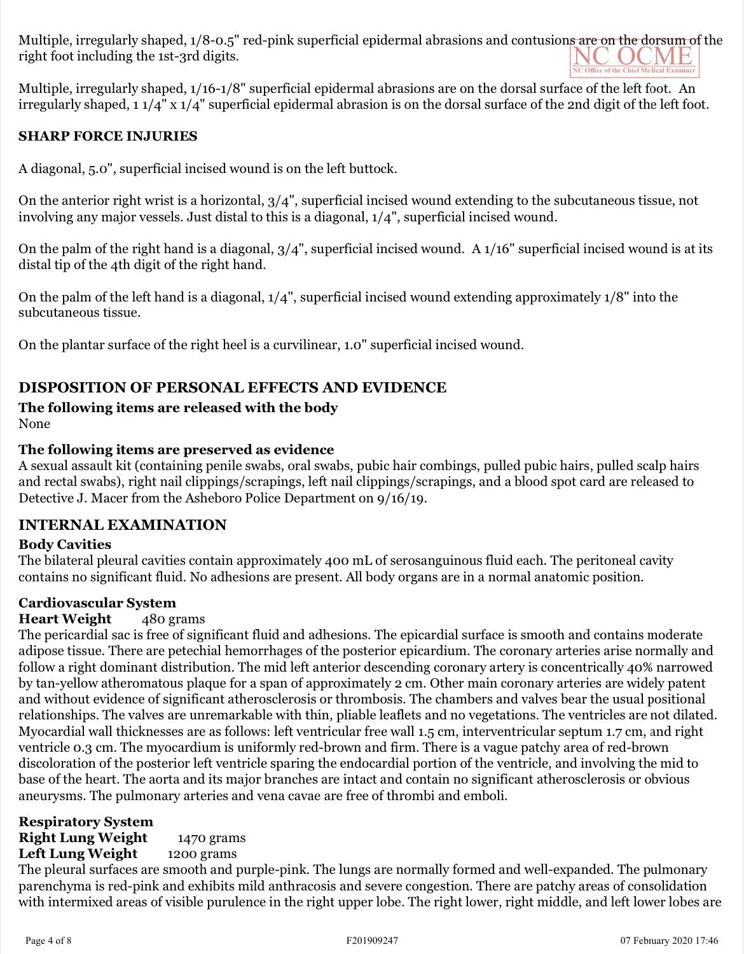

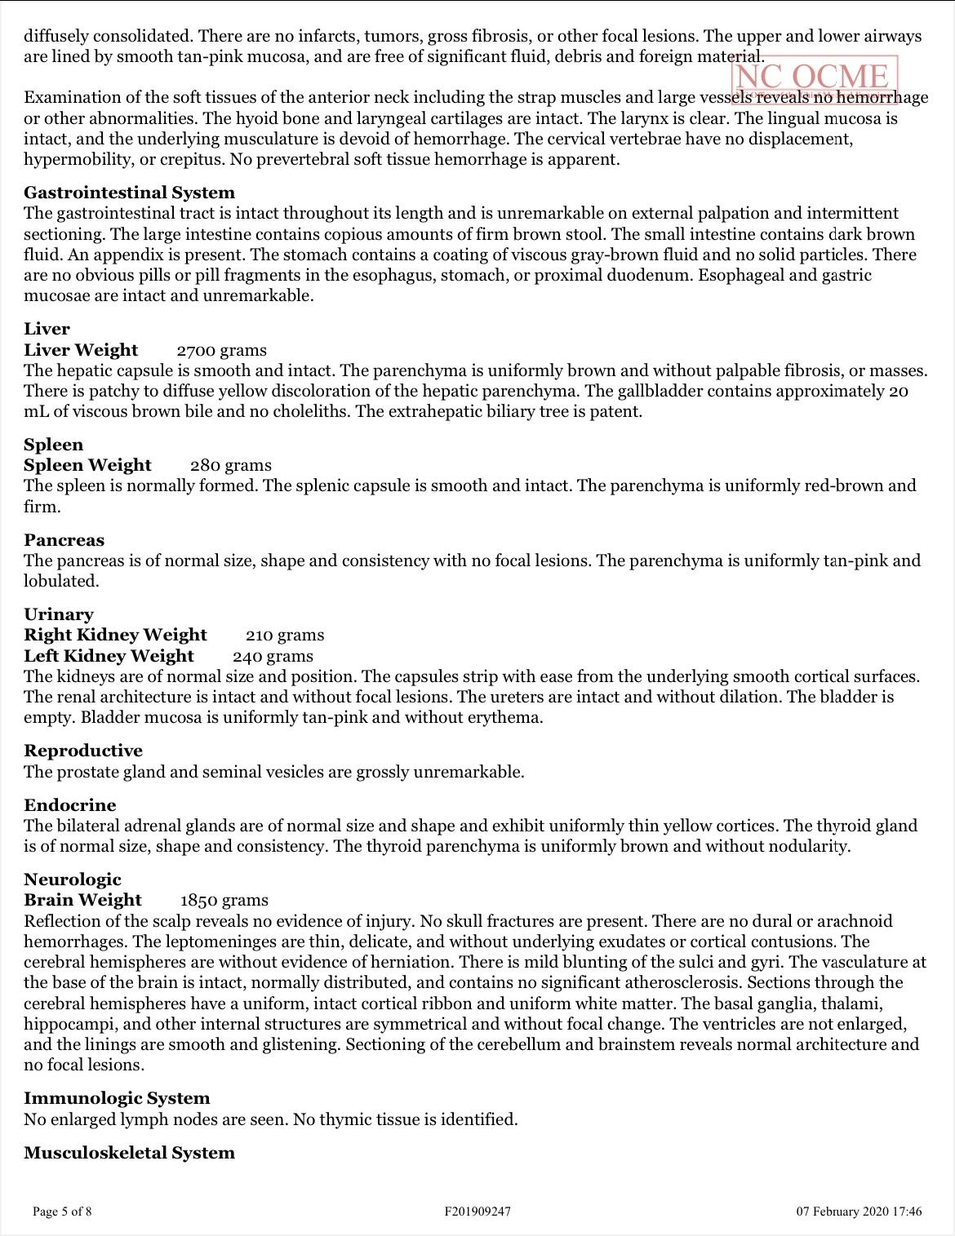

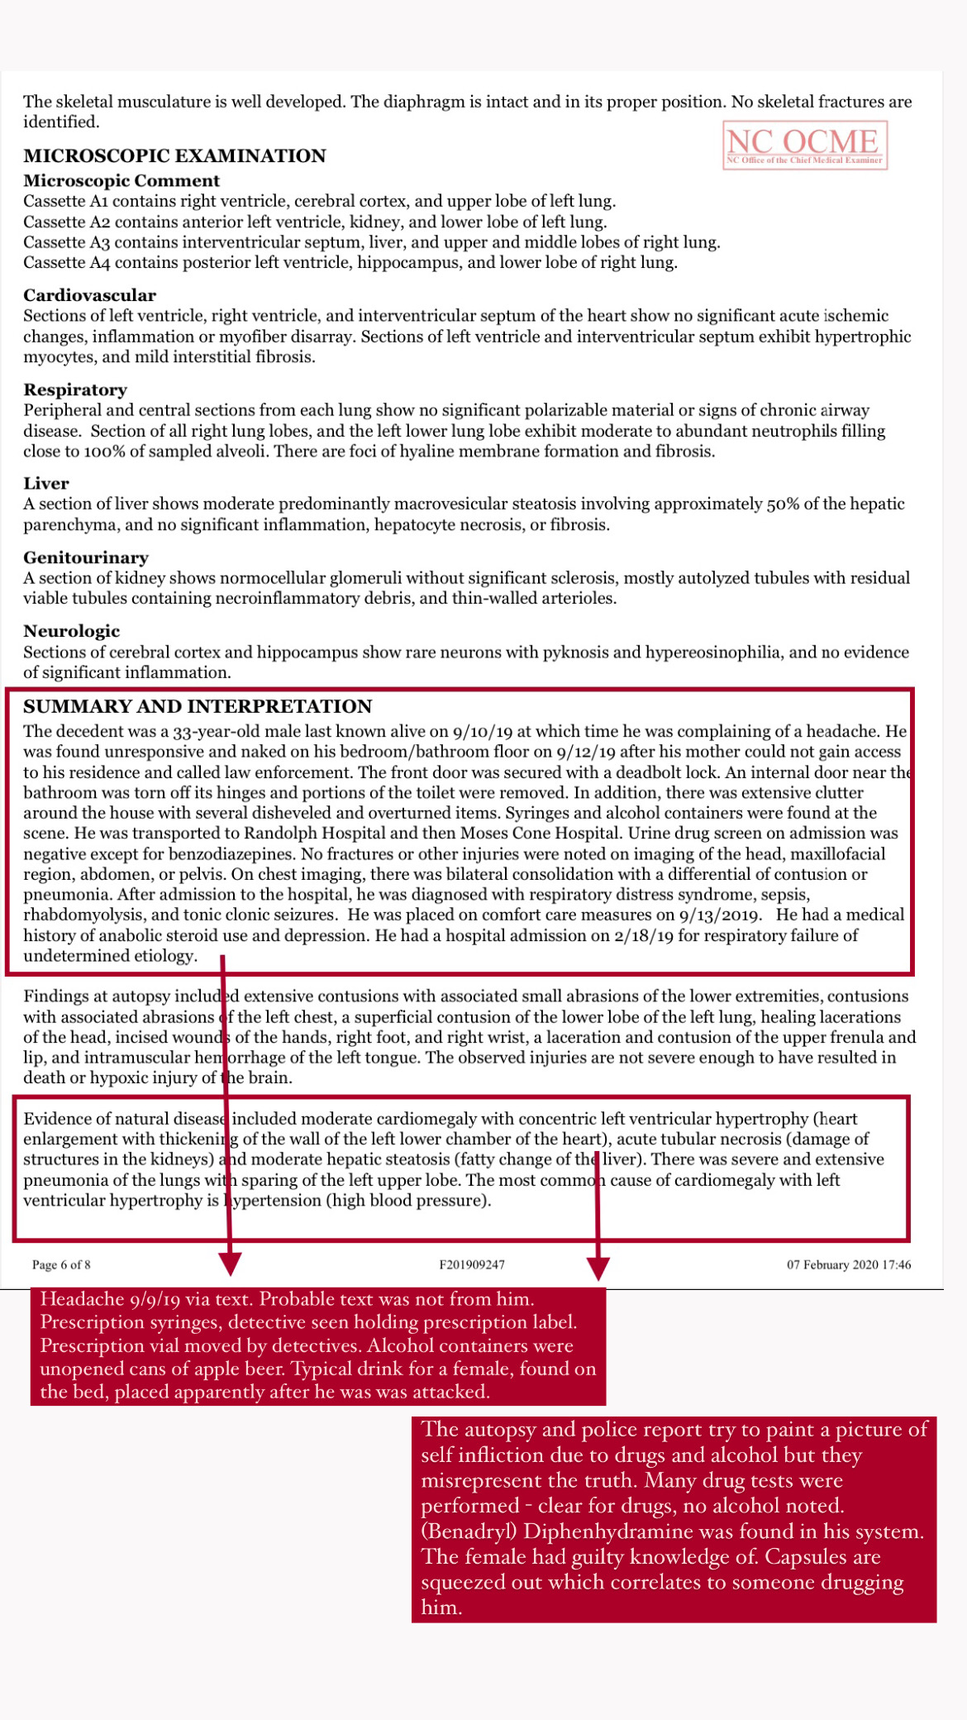

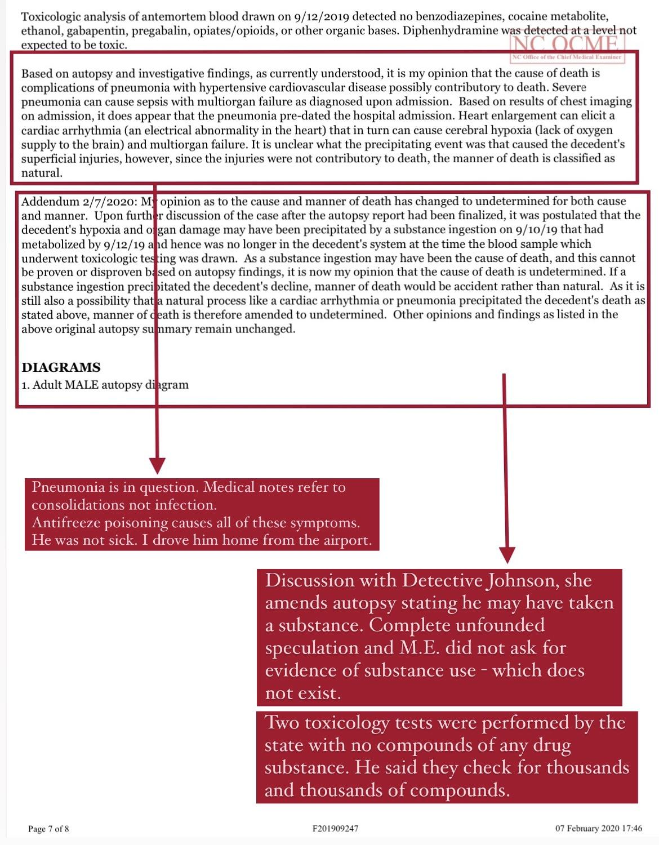

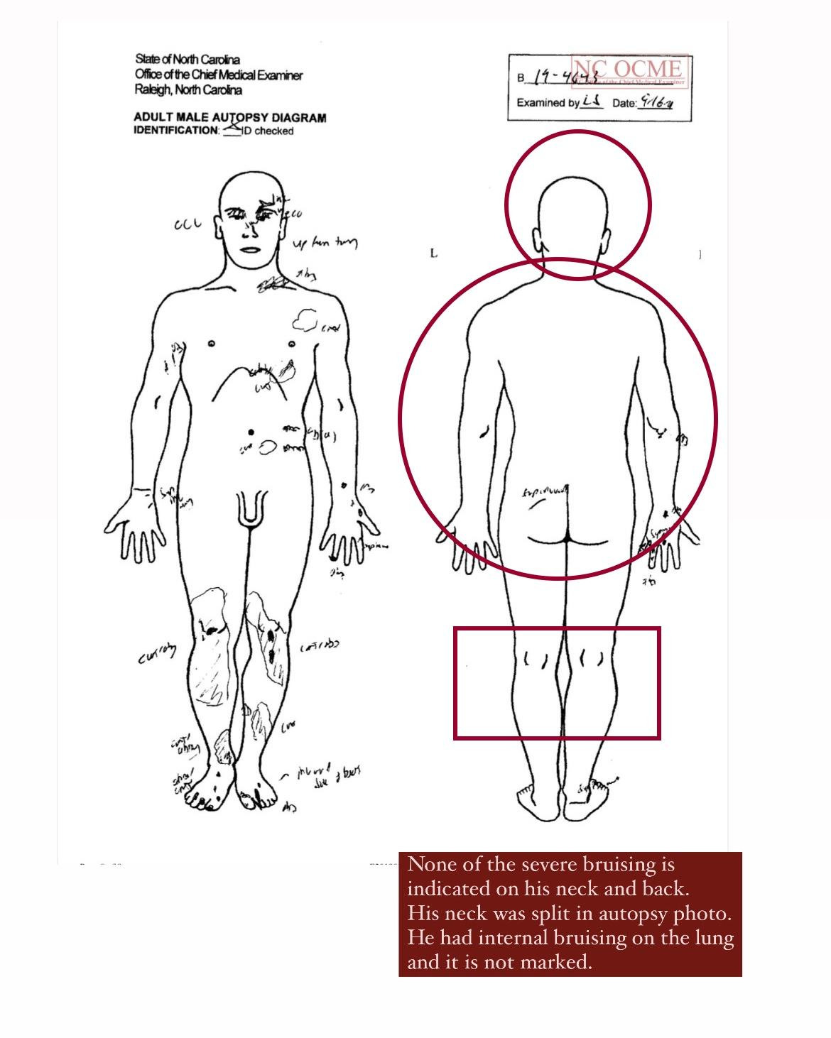
Bruising missing on backs of knees, head, neck, back, and sides. Split in neck not indicated.

